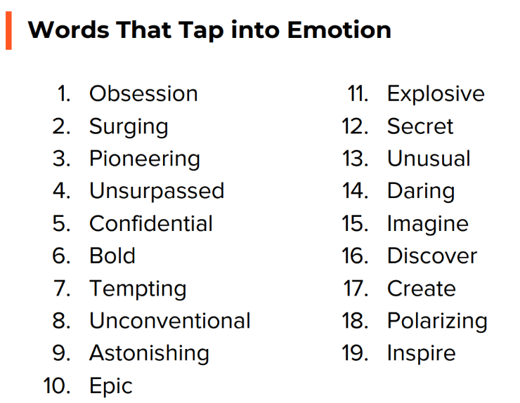1**00 marketing words to use:**

**75 marketing words to avoid:**

